Registration number :15BCE0552

Name: Gahana Agarwal

Slot: L23+L24

JavaScript Basics

1) To get a hang of JS just create a form with one text box for name and display the name entered using javascript

Code:

<html>

<head>

<script>

function result (form) {

var testvar=form.inputbox.value;

alert("You typed:" + testvar);

}

</script>

</head>

<body>

<form>

<input type="text" name="inputbox">

<button type="submit" onClick="result(this.form)">Submit

</form>

</body>

</html>

Screenshots:

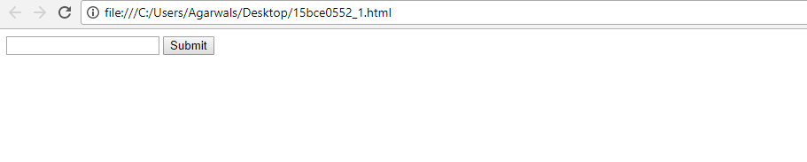

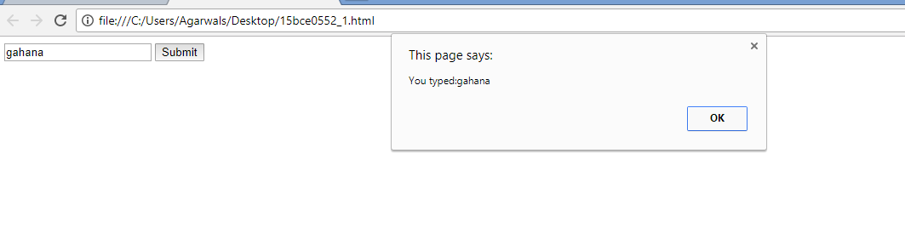

**2) Design a calculator for performing basic arithmetic operations (should also look like a calculator)**

**3) Once the basic calculator is working, try expanding it to include scientific operations like log, sine, cosine, tan, power, square root etc**

Code:

<html>

<head>

<style>

body

{

background-color:white;

}

.box

{

background-color:black;

height:400px;

width:250px;

border-radius:10px;

position:relative;

top:80px;

left:40%;

}

.display

{

background-color:gray;

width:220px;

position:relative;

left:15px;

top:20px;

height:40px;

}

.display input

{

position:relative;

left:2px;

top:2px;

height:35px;

color:black;

background-color:white;

font-size:21px;

text-align:right;

width:215px;

}

.keys

{

position:relative;

top:15px;

}

.button

{

width:40px;

height:30px;

border:none;

border-radius:8px;

margin-left:17px;

cursor:pointer;

border-top:2px solid transparent;

}

.button.gray

{

color:white;

background-color:#6f6f6f;

border-bottom:black 2px solid;

border-top:2px #6f6f6f solid;

}

.button.pink

{

color:black;

background-color:#ff4561;

border-bottom:black 2px solid;

}

.button.black

{

color:white;

background-color:303030;

border-bottom:black 2px solid;

border-top:2px 303030 solid;

}

.button.orange

{

color:black;

background-color:FF9933;

border-bottom:black 2px solid;

border-top:2px FF9933 solid;

}

.button.purple

{

color:white;

background-color:#AF7AC5;

border-bottom:black 2px solid;

border-top:2px #AF7AC5 solid;

}

.gray:active

{

border-top:black 2px solid;

border-bottom:2px #6f6f6f solid;

}

.pink:active

{

border-top:black 2px solid;

border-bottom:#ff4561 2px solid;

}

.black:active

{

border-top:black 2px solid;

border-bottom:#303030 2px solid;

}

.orange:active

{

border-top:black 2px solid;

border-bottom:FF9933 2px solid;

}

.purple:active

{

border-top:black 2px solid;

border-bottom:#AF7AC5 2px solid;

}

p

{

line-height:10px;

}

</style>

</head>

<body>

<div class="box">

<div class="display"><input type="text" readonly size="18" id="d"></div>

<div class="keys">

<p>

<input type="button" class="button gray" value="mrc" onclick='c("Created........")'>

<input type="button" class="button gray" value="m-" onclick='c("......by......")'>

<input type="button" class="button gray" value="m+" onclick='c(".......Gahana")'>

<input type="button" class="button pink" value="/" onclick='v("/")'>

</p>

<p>

<input type="button" class="button black" value="7" onclick='v("7")'>

<input type="button" class="button black" value="8" onclick='v("8")'>

<input type="button" class="button black" value="9" onclick='v("9")'>

<input type="button" class="button pink" value="*" onclick='v("*")'>

</p>

<p>

<input type="button" class="button black" value="4" onclick='v("4")'>

<input type="button" class="button black" value="5" onclick='v("5")'>

<input type="button" class="button black" value="6" onclick='v("6")'>

<input type="button" class="button pink" value="-" onclick='v("-")'>

</p>

<p>

<input type="button" class="button black" value="1" onclick='v("1")'>

<input type="button" class="button black" value="2" onclick='v("2")'>

<input type="button" class="button black" value="3" onclick='v("3")'>

<input type="button" class="button pink" value="+" onclick='v("+")'>

</p>

<p>

<input type="button" class="button black" value="0" onclick='v("0")'>

<input type="button" class="button black" value="." onclick='v(".")'>

<input type="button" class="button black" value="C" onclick='c("")'>

<input type="button" class="button orange" value="=" onclick='e()'>

</p>

<p>

<input type="button" class="button purple" value="sin" onclick='sine'>

<input type="button" class="button purple" value="cos" onclick='v("cos")'>

<input type="button" class="button purple" value="^2" onclick='v("^2")'>

<input type="button" class="button purple" value="log" onclick='v("log")'>

</p>

</div>

</div>

<script>

function c(val)

{

document.getElementById("d").value=val;

}

function v(val)

{

document.getElementById("d").value+=val;

}

function e()

{

try

{

c(eval(document.getElementById("d").value))

}

catch(e)

{

c('Error')

}

}

function sine(val)

{

var x=Math.sin(val);

document.getEmentById("d").value=x;

}

function cos(val)

{

var y=Math.cos(val);

document.getElementById("d").value=y;

}

function square(val);

{

document.getElementById("d").value=val*val;

}

function logs(val);

{

var z=Math.log(val);

document.getElementById("d").value=z;

}

}

</script>

</body>

</html>Screenshots:

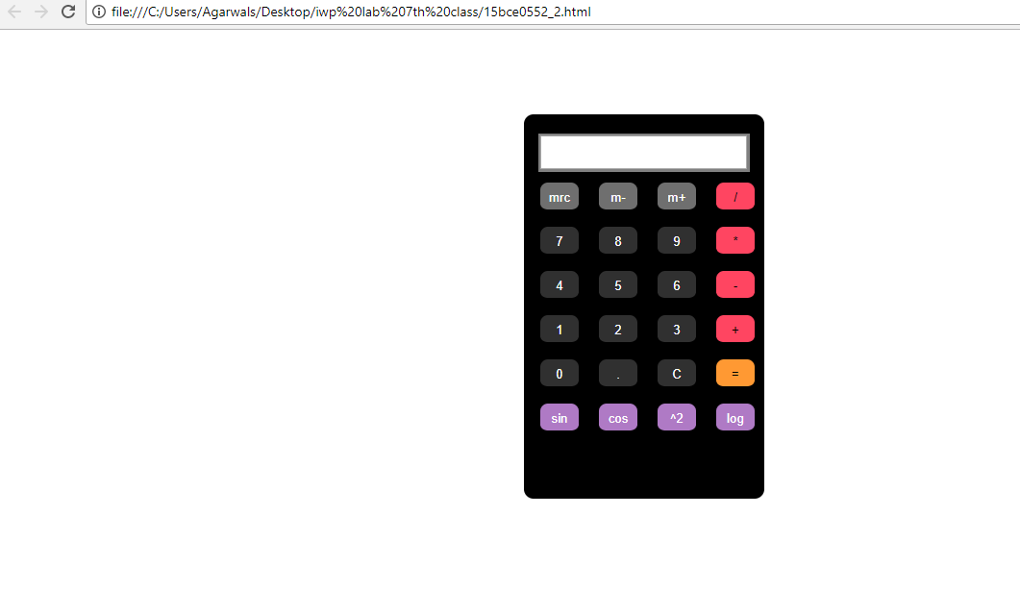

**Time Functions**

**1) Display a digital clock on a web page (a good looking one!!)**

**2) Once you have the clock running, implement the alarm and stopwatch functionalities.**

Code:

<html>

<head>

<style>

body {

padding:5cm;

background-color:tan;

}

#box {

background-color:black;

border:2px solid gray;

width:7cm;

height:4cm;

border-radius:15px;

}

#display {

color:black;

background-color:white;

border:1px solid black;

margin:15px;

height:1cm;

font-size:0.8cm;

text-align:center;

}

#a {

border:1px solid #8E44AD;

background-color:#8E44AD;

border-radius:20px;

width:1.5cm;

height:1cm;

margin:10px;

font-size:0.4cm;

color:white;

}

#reset {

border:1px solid #8E44AD;

background-color:#8E44AD;

border-radius:20px;

width:1.5cm;

height:1cm;

margin:10px;

font-size:0.4cm;

color:white;

}

#start {

border:1px solid green;

background-color:green;

border-radius:20px;

width:1.5cm;

height:1cm;

margin:10px;

font-size:0.4cm;

color:white;

}

#stop {

border:1px solid red;

background-color:red;

border-radius:20px;

width:1.5cm;

height:1cm;

margin:10px;

font-size:0.4cm;

color:white;

}

#ii1 {

border:1px solid black;

width:100px;

height: 40px;

}

#ii2 {

border:1px solid black;

width:100px;

height: 40px;

}

#para2 {

background-color:white;

}

</style>

<script>

function startTime() {

var today = new Date();

var h = today.getHours();

var m = today.getMinutes();

var s = today.getSeconds();

m = checkTime(m);

s = checkTime(s);

document.getElementById('display').innerHTML =

h + ":" + m + ":" + s;

var t = setTimeout(startTime, 500);

}

function checkTime(i) {

if (i < 10) {i = "0" + i}; // add zero in front of numbers < 10

return i;

}

</script>

</head>

<body onload="startTime()">

<div id="box">

<p id="display"></p>

<input type="number" max="23" min="0" placeholder="Hours" name="aih" id="ii1"/>

<input type="number" max="59" min="0" placeholder="Minutes" name="aim" id="ii2"/>

</div>

<button id="a" onClick="alarm()">Set<br>Alarm</button> <button id="reset">Reset</button> <br>

<p id="para2"></p> <br> <button id="start" onClick="swatch()">Start</button> <button id="stop" onClick="stop()">Stop</button>

</div>

<script>

function alarm() {

var h1=document.getElementById("ii1").value;

var m1=document.getElementById("ii2").value;

if (h1=h && m1=m) {

alert("Wake up");

}

setInterval(alarm,500);

}

function swatch()

{ sh=0;

sm=0;

ss=0;

flag=1;

stopwatch();

}

function stopwatch()

{ ss+=1;

if(ss==60)

{ ss=0;

sm+=1;

}

if(sm==60)

{ sh=0;

}

var h=checkTime(sh)

var m=checkTime(sm);

var s=checkTime(ss);

document.getElementById('para2').innerHTML=h+":"+m+":"+s;

if (flag==1)

{ varstime=setTimeout(stopwatch, 500);

}

}

function stop()

{ flag=0;

}

</script>

</body>

</html>

Screenshots:

